**CONUMER CLUB ACHIEVEMENTS – 2021 AND 2022**

**NATIONAL CONSUMER DAY WAS CONDUCTED IN OUR COLLEG ON 24.12.2022**

In view of the above, Students Our college participated in District level and State level competitions of and won prizes too.

1. P. LOKESH
2. Y. JYOTHI
3. P. PRAVALLIKA
4. T. TULASI

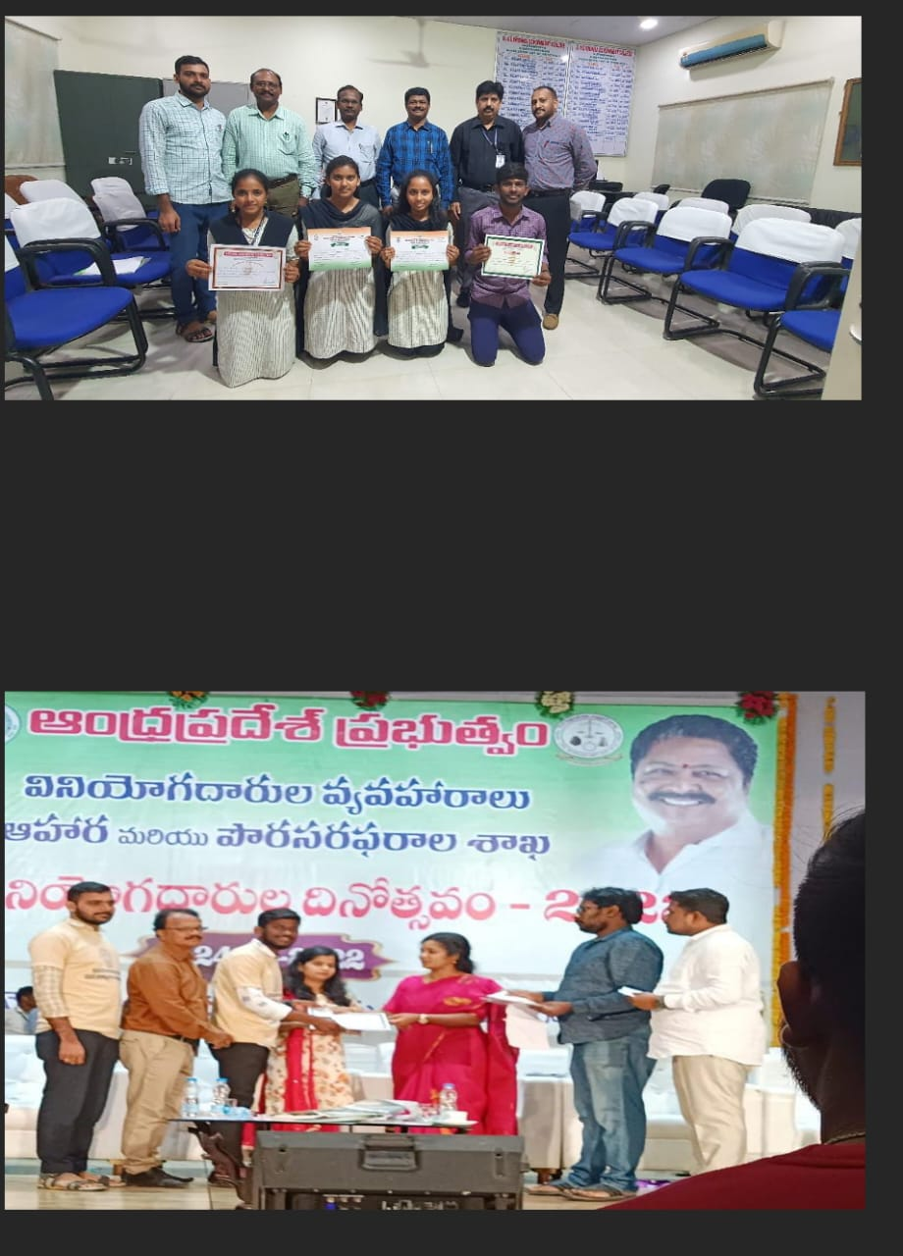

**CONSUMER CLUB ACHIEVEMENTS – 2021**

**NATIONAL CONSUMER DAY WAS CONDUCTED IN OUR COLLEG ON 24.12.2021**

In view of the above, Students Our college participated in District level and State level competitions of and won prizes too.

